**March 25, 2020**



**Virtual Immersion Day**

Data Lake with AWS – Lab Preparation Doc

# **Lab Pre-Requisites**

In order to complete the immersion day labs, please follow the preparation steps outlined below:

1. **AWS Account Setup:**
   1. In order for you to complete the labs for today's immersion day, you must log into an AWS Burner account that has been created for you: <https://dashboard.eventengine.run/login>
   2. Access to this burner account requires a 12 digit hash key that has been sent to the email you just registered with. Please check your email and copy the hash to login into this burner account using the link above.

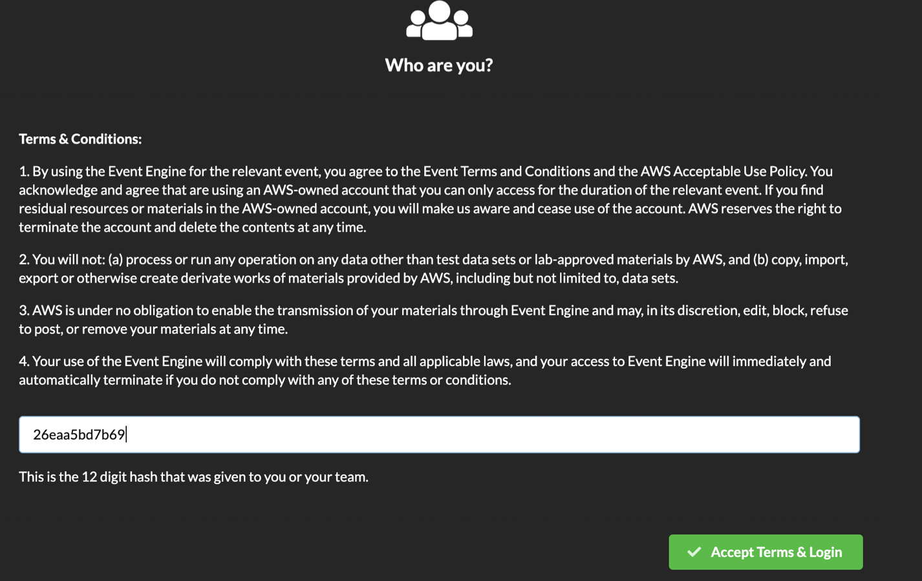

* 1. By clicking ‘Accept Terms & Login’, you will be taken to the ‘Team Dashboard’ page (as shown below)

Please click ‘AWS Console’

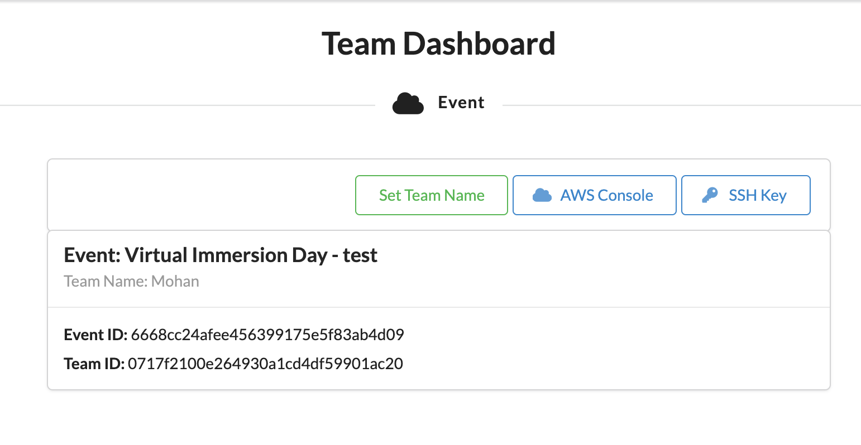

* 1. Please click ‘Open AWS Console’ (as shown within the screenshot below) and it should take you right into the AWS console landing page.

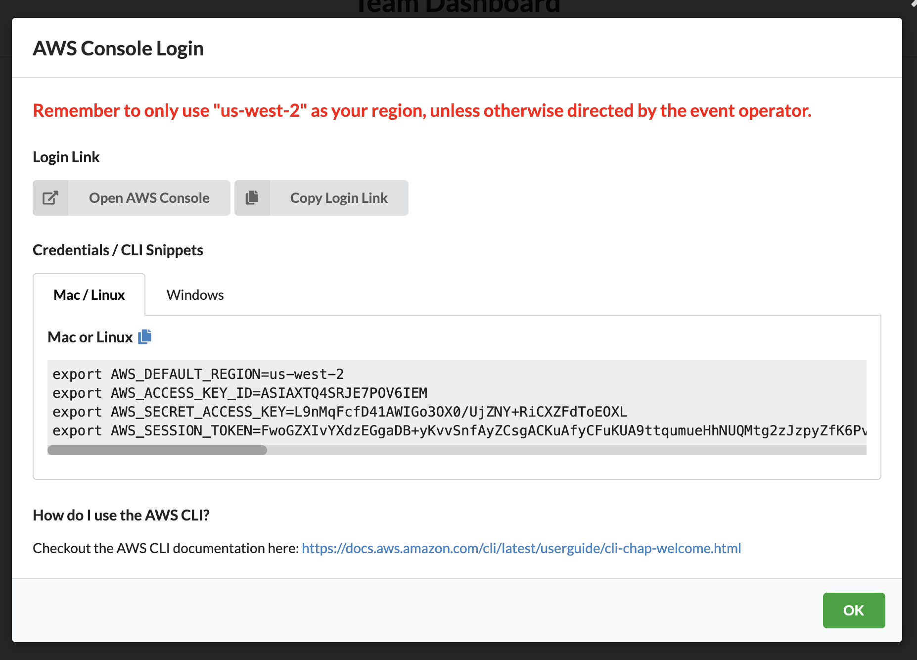

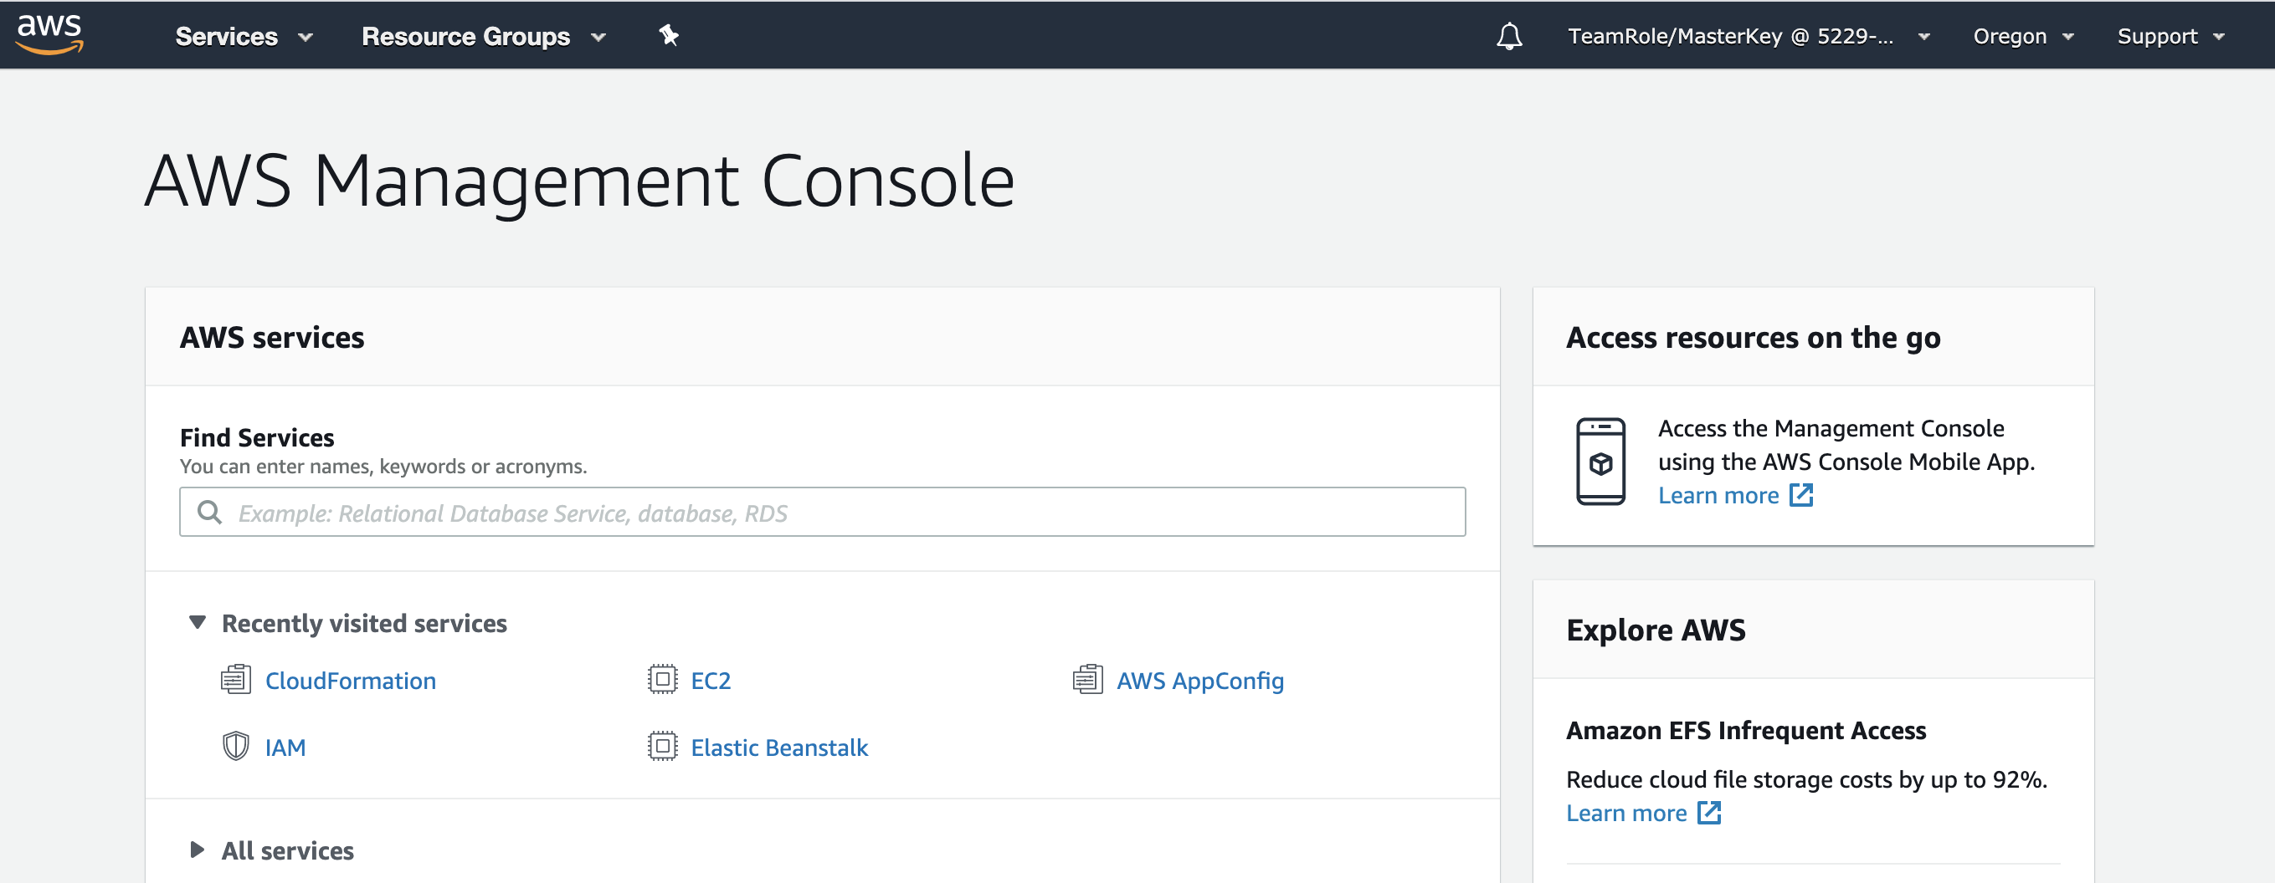

**Note on AWS Regions:** You can run the labs in any region except for the lab related to the Kinesis Data Generator tool, which requires us-west-2 (Oregon) region. Make sure your AWS account doesn’t have restrictions for us-west-2 region for this lab.

1. **Kinesis Data Generator Tool:** 
   1. Follow the KDG Guide on <https://awslabs.github.io/amazon-kinesis-data-generator/web/help.html> to install and configure the KDG on your AWS account.

You simply need to use the CloudFormation template to create KDG within the us-west-2 (Oregon) region.

* 1. Click the ‘Create a Cognito User with CloudFormation’ button within the url above to get to the CloudFormation console.
  2. Retain the defaults within the ‘Specify template’ page and click ‘Next’
  3. While in Step 2 of the process, provide the ‘Stack name’ as ‘Kinesis-Data-Generator-Cognito-User’ along with your desired ‘Username’ and ‘Password’ (as shown in the screenshot below)
     1. Username: kdgpoc
     2. Password (e.g. Kdgpoc1432)

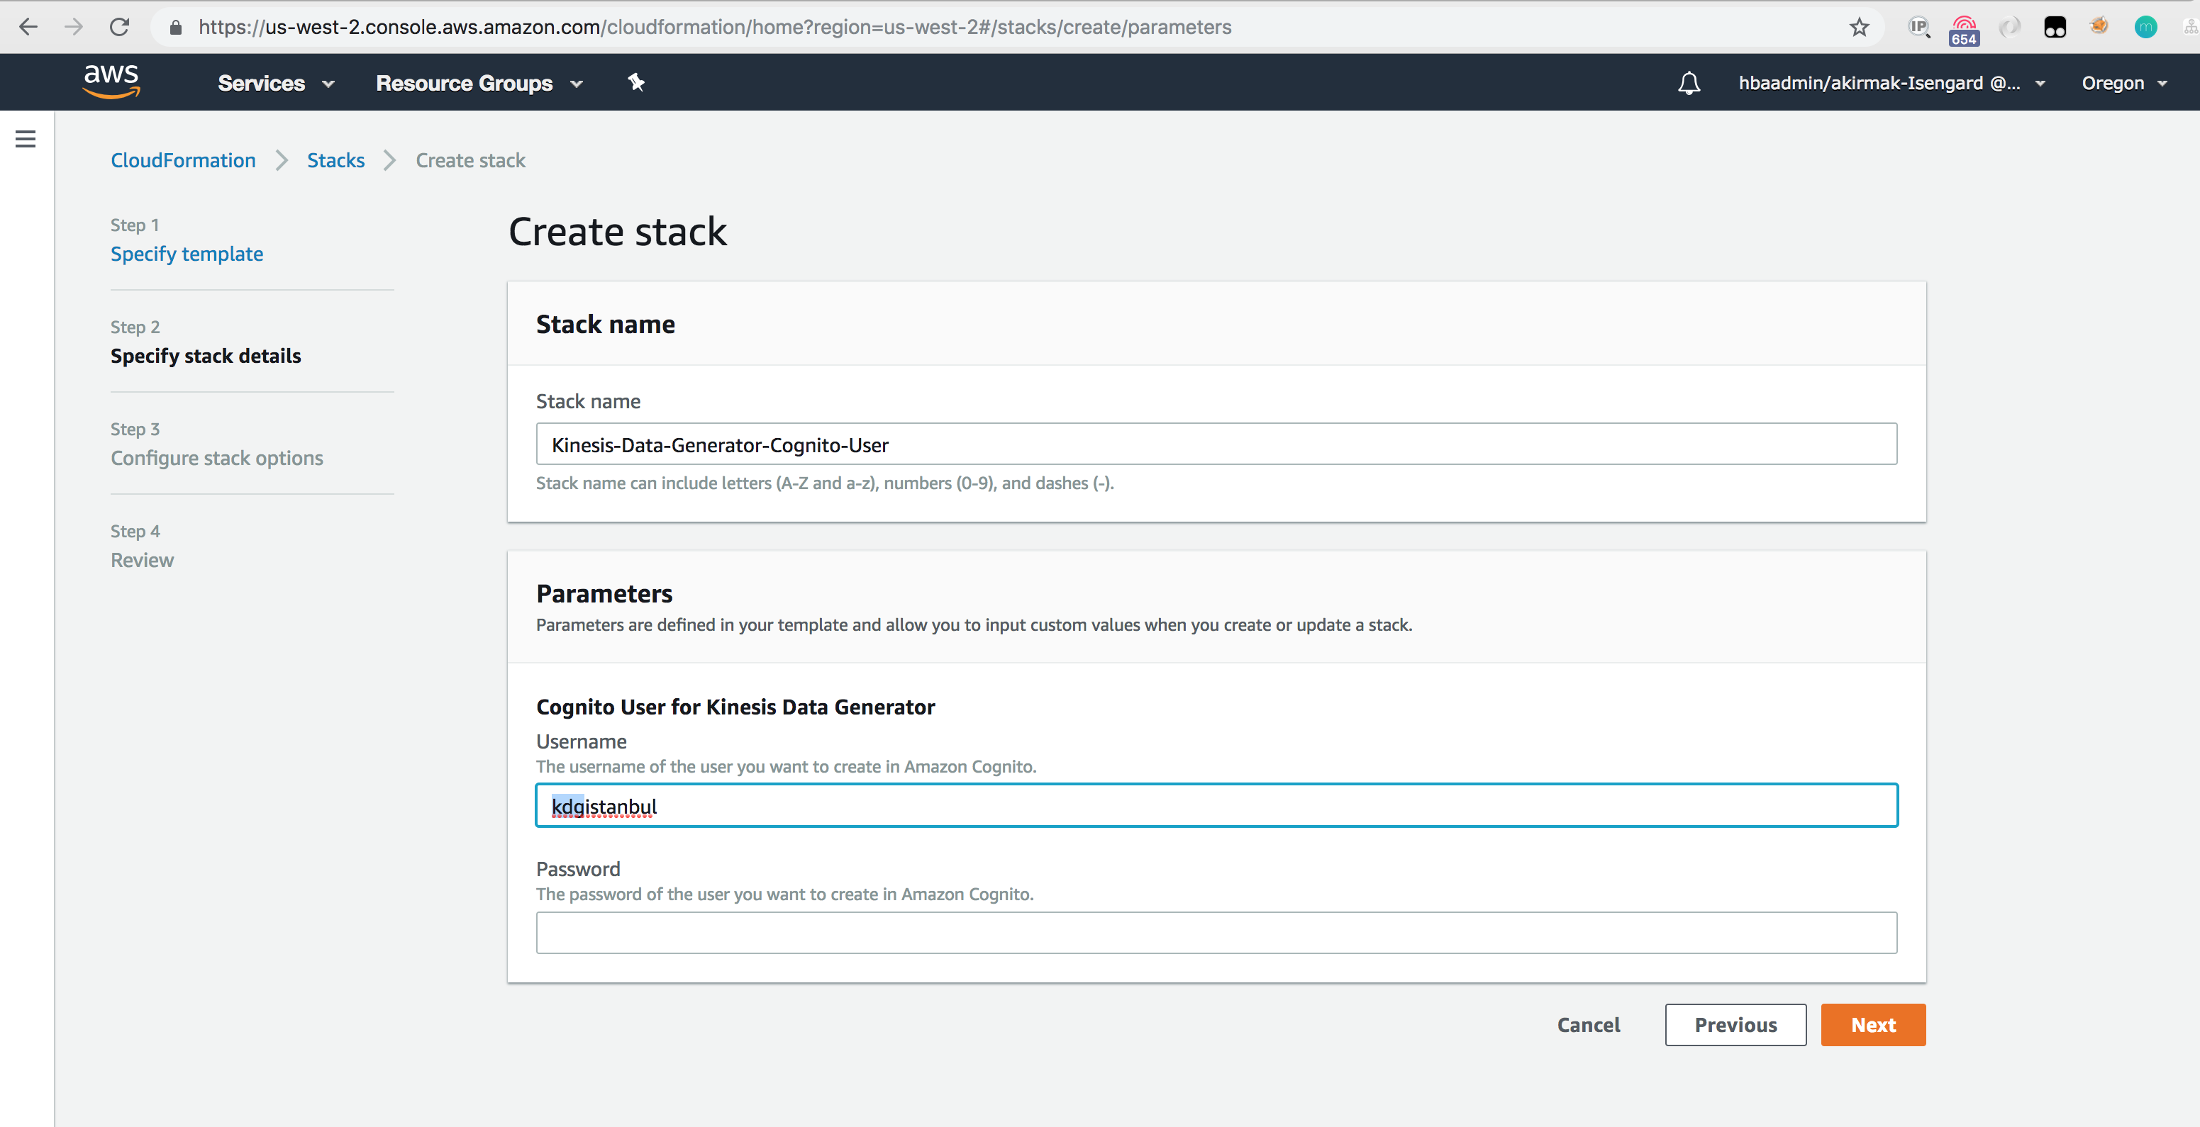

The stack creates a user password in a User DataBase (called User Pool) using the Amazon Cognito service.

* 1. Retain all the defaults and move further to the last step. Select the checkbox ‘I acknowledge AWS CloudFormation might create IAM resources’ and choose ‘Create Stack’

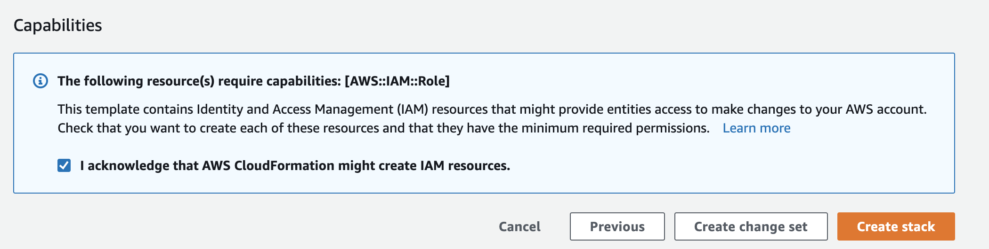

1. **CloudFormation Stack Creation for Service Role Permissions:**

We have written a CloudFormation template that creates the IAM roles and policies you’d need to run the labs. They authorize the services used within the labs. The template file ‘**serverlessDataLakeCF.json**’ can be found under the ‘Files’ section of the adobe connect meeting.

* 1. Download and save the JSON file **serverlessDataLakeCF.json** from the ‘Files’ section of the meeting into your computer.

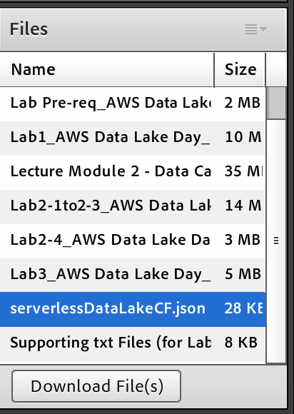

* 1. Open CloudFormation console.
     1. Select “Create Stack” and chose “With new resources (standard)” to move further

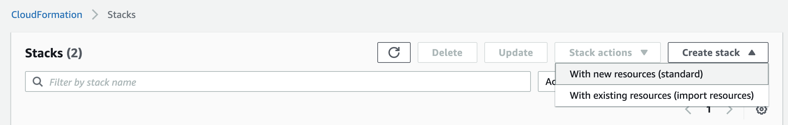

* + 1. Choose “Upload a template file” to choose and upload the **serverlessDataLakeCF.json** file and click Next.

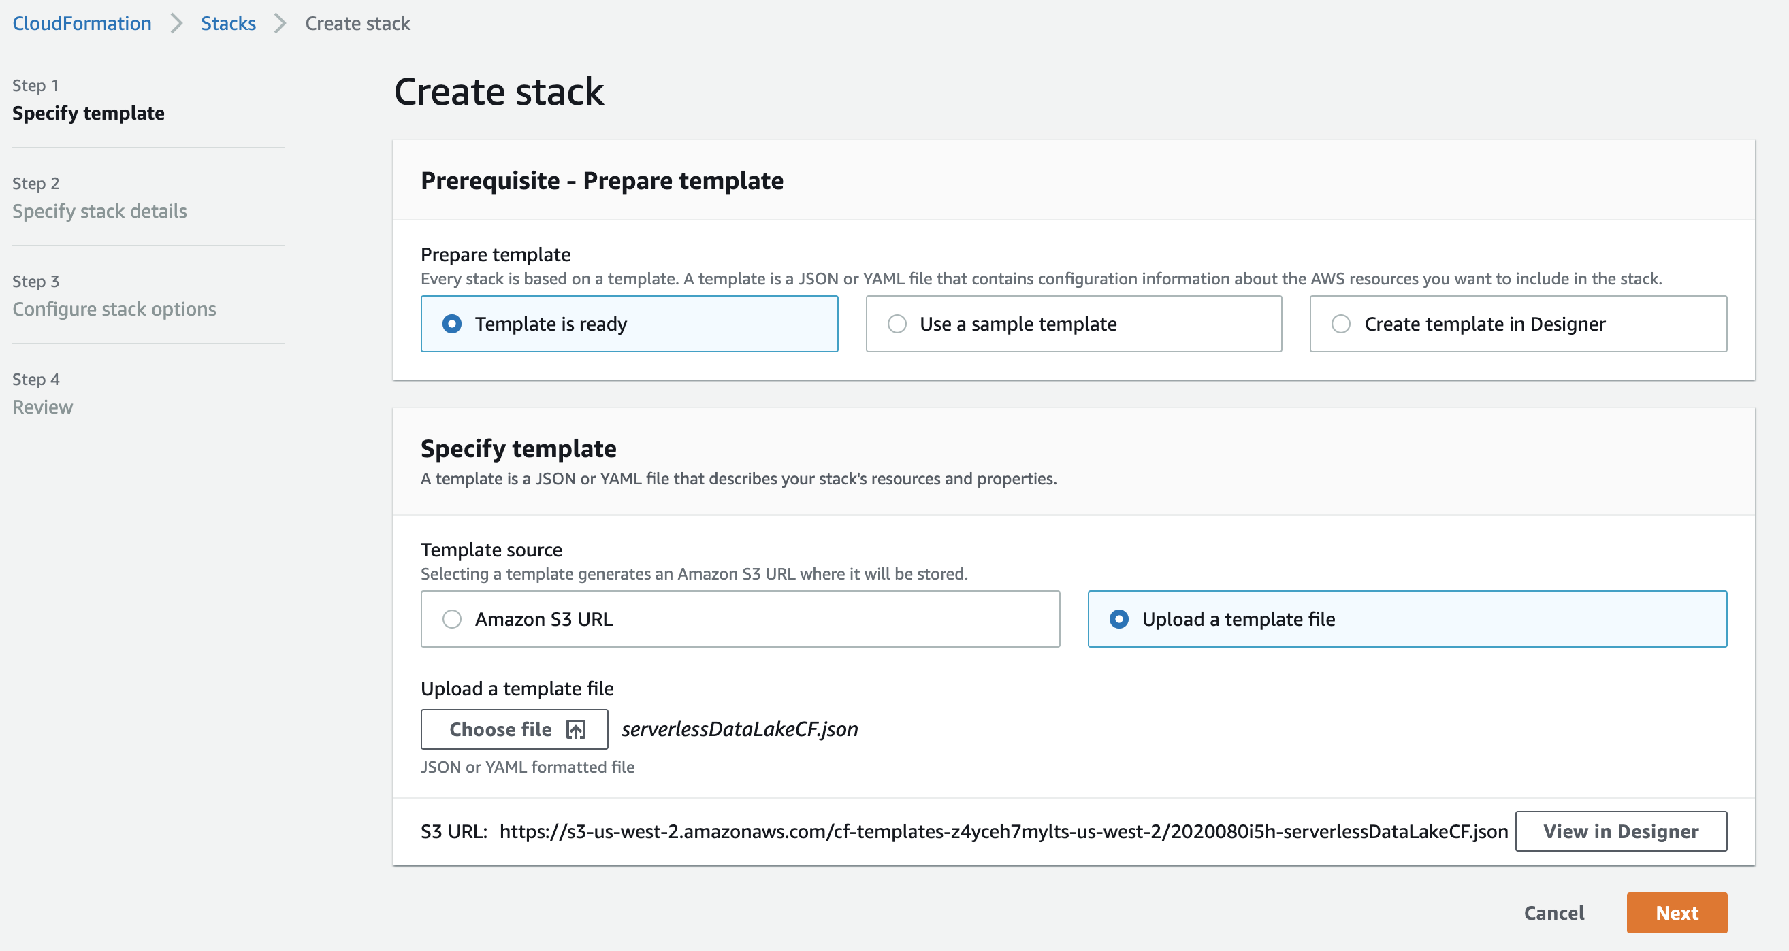

* + 1. Enter Stack name as “sdlimmersion” and under the Parameters section, provide a value within the ‘yourinitials’ field (as shown in the image below) 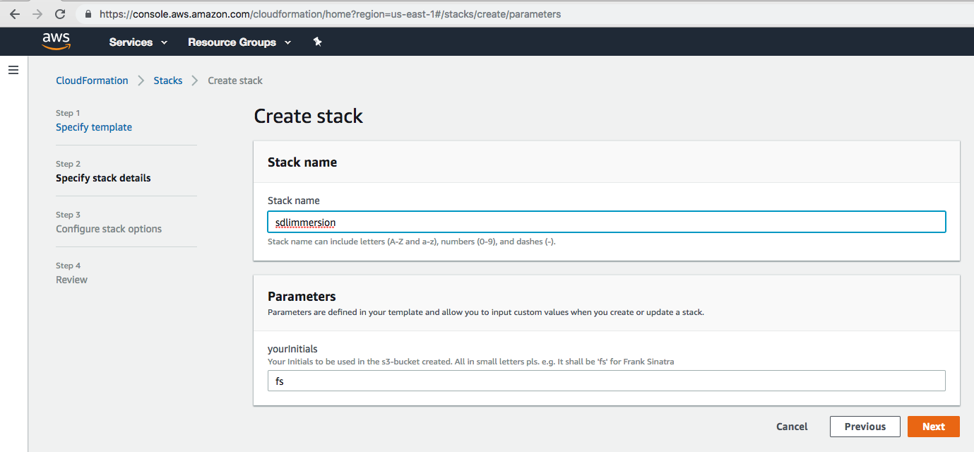
  1. Retain all the defaults and move further to the last step. Select the checkbox ‘I acknowledge AWS CloudFormation might create IAM resources’ and choose ‘Create Stack’

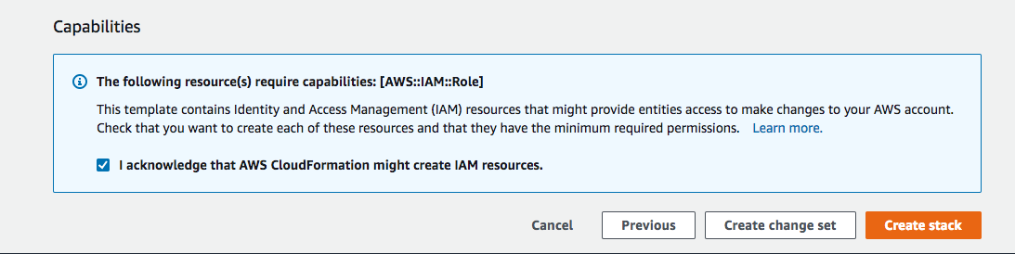

**Finally, you should be seeing both the stacks being successfully created by validating the status within the CloudFormation landing page (as shown below)**

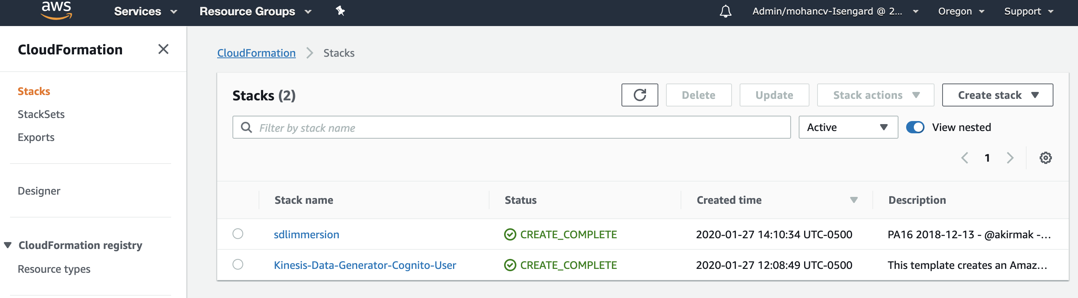

**This concludes the pre-requisites and you should be good to proceed further with the labs.**